**Data-Driven Insights for Optimizing Movie Rental Business Performance**

**1. Business Problem**

In the highly competitive movie rental industry, understanding customer preferences, managing inventory efficiently, and optimizing revenue are pivotal to ensuring sustainable growth. The movie rental store faces several challenges, including:

* **Customer Retention & Engagement**: Understanding why certain customers are more active and how to target inactive customers.
* **Revenue Optimization**: Identifying which film categories, rental rates, and geographic regions contribute most to revenue.
* **Inventory Management**: Determining the best strategies for stocking popular films and managing underperforming categories.
* **Staff and Operational Efficiency**: Analyzing staff performance to optimize workload distribution and improve overall efficiency.
* **Market Expansion**: Understanding the geographical distribution of customers to aid in strategic decisions for expanding store locations and services.

The solution to these challenges lies in leveraging comprehensive data analysis to inform strategic business decisions, enhance operational efficiency, and improve customer satisfaction.

**2. Data Requirement**

For the analysis of the movie rental store’s operations, the following data sets are essential:

* **Customer Data**: Information about customer demographics, rental frequency, and movie preferences.
* **Film Data**: Data regarding film titles, categories, ratings, and rental prices.
* **Rental Transactions**: Details of each rental, including rental duration, payment history, and return status.
* **Staff Data**: Information on staff performance, including the number of rentals processed and customer interactions.
* **Geographical Data**: Location-based data to understand regional trends in customer behavior and rental frequency.
* **Revenue Data**: Breakdown of revenue by film category, rating, and country to understand financial dynamics.

These data points provide a holistic view of the movie rental operations and customer behavior, enabling a deeper understanding of key business drivers.

**3. Data Collection and Data Understanding**

Data was collected from the movie rental database, which includes multiple tables detailing films, customers, rentals, staff, and transactions. The key data sources are:

* **Customer Table**: Contains information about each customer, such as their ID, name, contact details, and activity status.
* **Film Table**: Information on all films, including title, release year, genre, rental rates, and rental duration.
* **Rental Table**: Records all rental transactions, including rental dates, return dates, and associated payments.
* **Payment Table**: Contains details about payments, including amounts and associated rentals.
* **Location Table**: Stores customer addresses, which are used to analyze geographic trends.

The initial step involved conducting **Exploratory Data Analysis (EDA)** using SQL to examine the relationships between these variables, uncover trends, and identify patterns that affect business outcomes.

**4. Data Validation**

The data validation process ensures that the analysis is unbiased, transparent, and reliable. Key considerations included:

* **Bias Prevention**: Ensuring that data samples reflect the actual distribution of customers, films, and rentals without any overrepresentation of particular groups or categories.
* **Transparency**: All data sources, transformations, and analysis steps were clearly documented to maintain transparency throughout the process.
* **Reliability**: Data integrity was validated by checking for missing values, inconsistencies, and logical errors (e.g., ensuring rental dates are valid and film IDs match in the rental data).

For example, missing customer data or incomplete rental transactions were identified and handled through imputation or removal, depending on their impact on the analysis.

**5. Data Cleaning (EDA) (Python/SQL)**

Data cleaning involved several key steps:

* **Outlier Detection**: Identified and removed extreme values that could skew analysis, such as unusually high rental rates or improbable rental durations.
* **Missing Data Handling**: Used imputation techniques to fill missing values, especially for customer activity status or film ratings, and removed rows where essential information was absent.
* **Normalization and Scaling**: Standardized numerical features, such as rental rates and revenue, to ensure consistency across different analysis metrics.
* **Data Type Conversion**: Ensured all columns had the appropriate data type (e.g., converting rental durations to numerical values for accurate analysis).

**Python** and **SQL** were used for these tasks, leveraging libraries like **pandas** for cleaning and transformation, and SQL queries to aggregate data from relational tables.

**6. Tools Selection**

The tools chosen for this analysis include:

* **Power BI**: For creating interactive dashboards that visualize the relationship between customer behaviors, film categories, and rental revenue. Power BI enables easy data exploration through filters and slicers, allowing business users to drill down into specific metrics and insights.
* **SQL**: For querying and aggregating large datasets from the movie rental database. SQL was essential for managing relational data and performing complex joins across different tables.
* **Excel**: Used for detailed calculations and supplementary visualizations that provide quick insights to stakeholders.

These tools were selected for their ability to handle large datasets, provide real-time insights, and enable interactive decision-making.

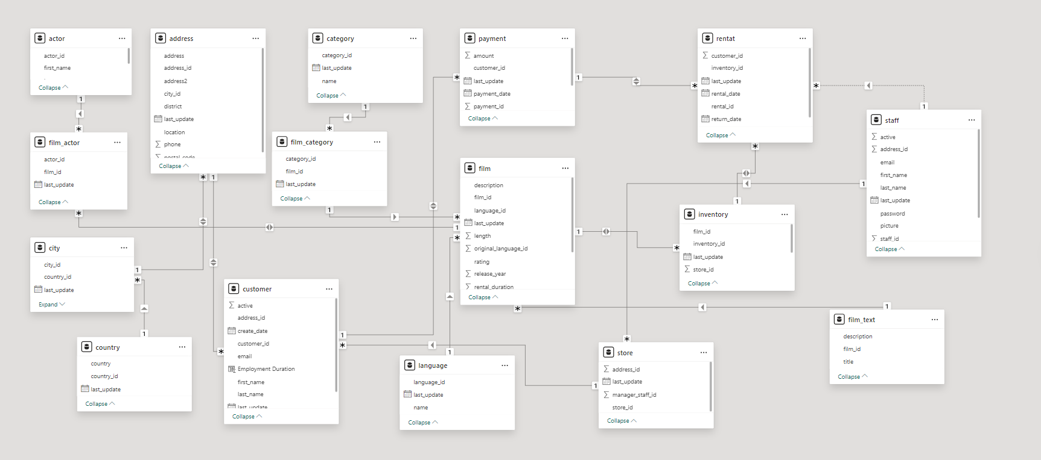

**7. Dashboard**

The **Power BI dashboard** provides a comprehensive, visual representation of key business metrics, including:

* **Revenue by Country**: A heatmap showing the geographical distribution of rental revenue, highlighting top-performing countries like India, China, and the United States.
* **Film Category Performance**: A bar chart displaying revenue and rental duration for each film category, helping identify the most profitable genres (e.g., Sports and Sci-Fi).
* **Customer Segmentation**: An analysis of active versus inactive customers, with targeted recommendations for re-engagement.
* **Rental Trends**: Line graphs depicting rental volume and revenue fluctuations across different months, enabling businesses to track seasonal patterns.
* **Actor Performance**: Insights into how individual actors impact rental rates and film popularity, helping to optimize casting decisions.

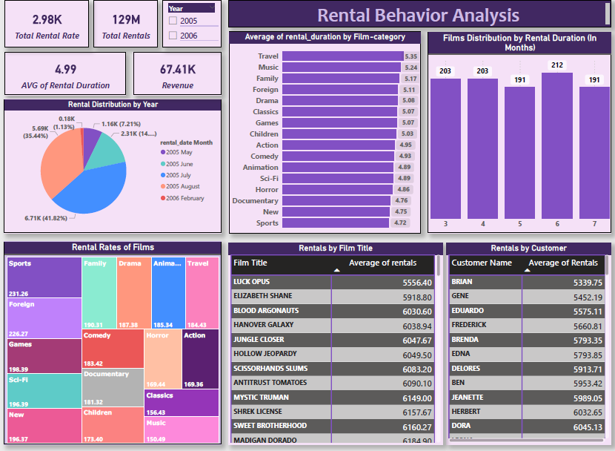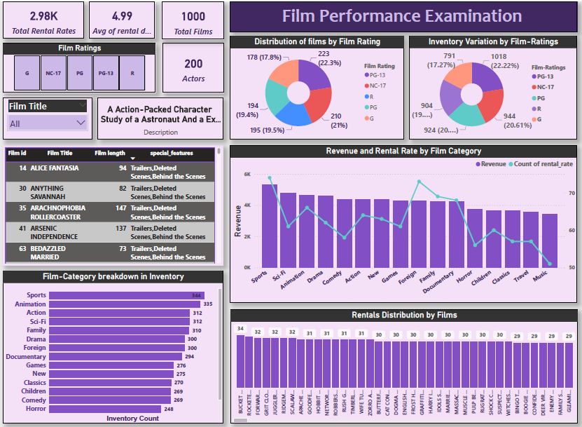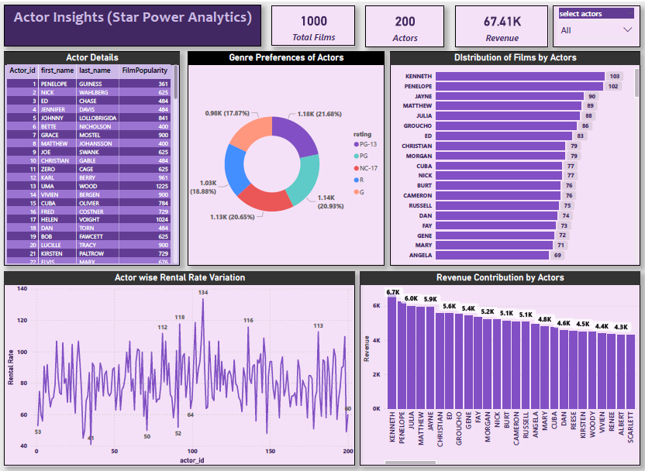

**8. Storytelling**

**Why This Approach Will Drive Business Success:**

1. **Customer-Centric Strategy**: By understanding customer preferences and segmenting them based on rental habits, the rental store can create tailored marketing campaigns to increase customer engagement. Targeting inactive customers with personalized offers or re-engagement strategies can significantly boost revenue.
2. **Optimized Inventory Management**: By analyzing which films are rented most frequently and categorizing them by genre, the rental store can adjust its inventory to ensure high-demand films are always available. This strategy reduces underperforming inventory and improves stock turnover.
3. **Revenue Optimization**: The analysis of revenue by country and film category reveals which regions and genres are most profitable. With this information, the business can focus on expanding operations in high-revenue countries and increase promotions for top-performing genres.
4. **Enhanced Decision-Making**: With interactive Power BI dashboards, decision-makers can visualize the impact of different strategies and track their effectiveness in real-time. This data-driven approach enables informed decisions that align with business objectives.
5. **Strategic Casting Decisions**: By understanding the revenue impact of different actors, the rental store can make informed decisions about which actors to focus on when acquiring films. Actors with higher revenue contributions can be prioritized in future acquisitions, driving profitability.